

semester project

Intro to ICT



June 18, 2022

Group members:

Mona Khalil (SP22-BSE_028)

Saira Batool (SP22-BSE_046)

Aimen Ghani (SP22-BSE_004)

Hasaan Ahmed (SP22-BSE_017)

**Introduction:**

Rock Paper Scissors, usually played between two people. It has three possible outcomes: a draw, a win or a loss. This game code is written on python and we can see its output on python console. You can play with computer as well as with your friend. Basic rule of game is as follows:

* Rock blunts Scissors (Rock wins over Scissors)
* Scissors cuts Paper (Scissor wins over Paper)
* Paper covers Rock (Paper wins over Rock)
* A tie results if both players choose the same option; in this case, players play another round to break the tie.

**Flowchart:**

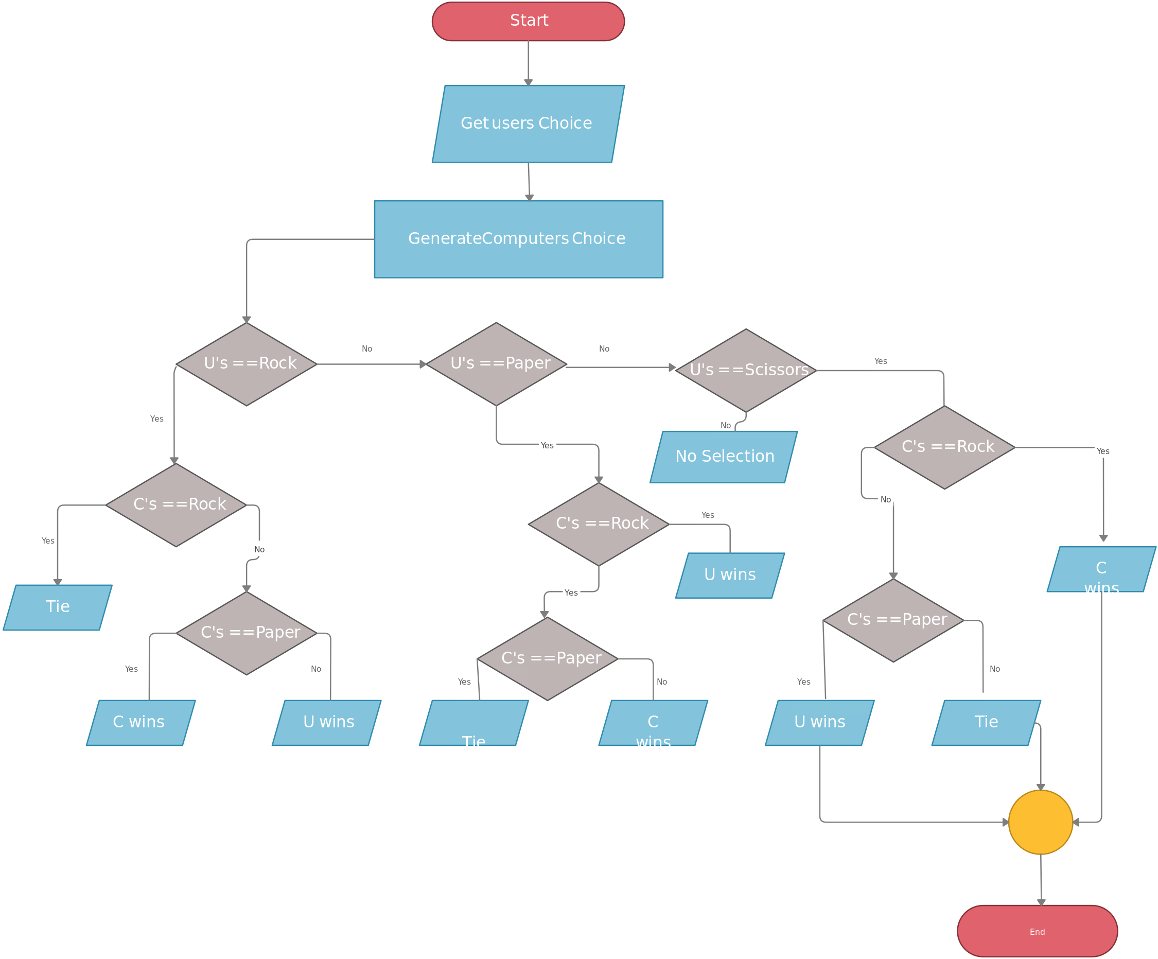

**Algorithm:**

1. User inputs rock, paper, or scissors
2. If user guesses rock, go to step 3.  If not, go to step 6.
3. Does computer guess rock?  If yes, go to step 14. If not, go to step 4.
4. Does computer guess paper?  If yes, go to step 15.  If not, go to step 5.
5. Does computer guess scissors?  If yes, go to step 16. If not, go to step 3.
6. If user guesses paper, go to step 7.  If not, go to step 10.
7. Does computer guess rock?  If yes, go to step 16. If not, go to step 8.
8. Does computer guess paper?  If yes, go to step 14.  If not, go to step 9.
9. Does computer guess scissors?  If yes, go to step 15. If not, go to step 7.
10. If user guesses scissors, go to step 11.  If not, go to step 3.
11. Does computer guess rock?  If yes, go to step 15. If not, go to step 12.
12. Does computer guess paper?  If yes, go to step 16.  If not, go to step 13.
13. Does computer guess scissors?  If yes, go to step 14. If not, go to step 11.
14. It’s a tie
15. Computer wins
16. User wins
17. Would you like to play again? If yes go to step 1, else continue
18. End

**Modules:**

**Random** module is used in this program. The random module is a built-in module to generate the pseudo-random variables. It can be used perform some action randomly such as to get a random number, selecting a random element from a list, shuffle elements randomly, etc.

We have called randint which is a function of random module.

**Output:**

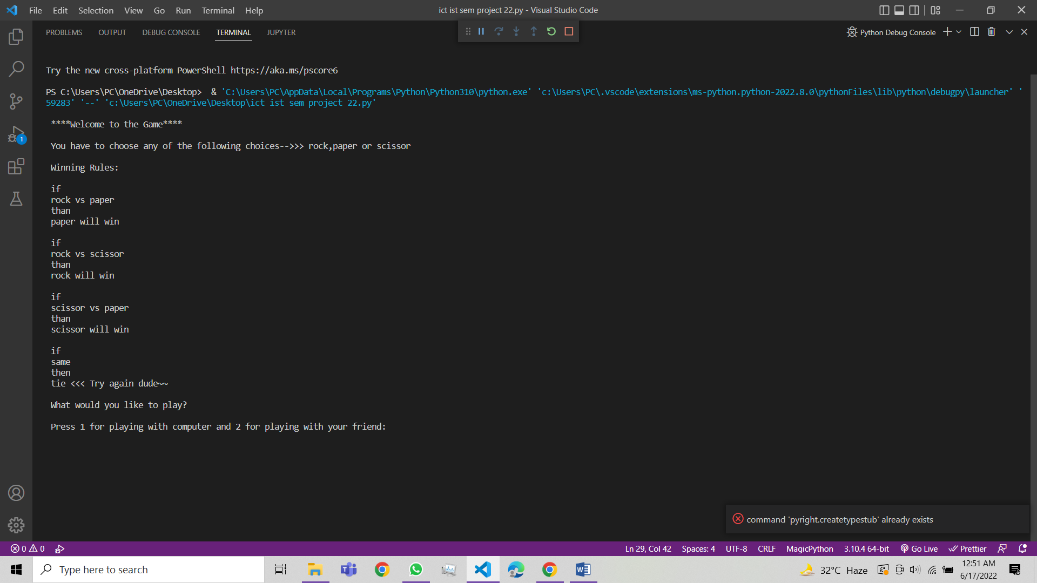

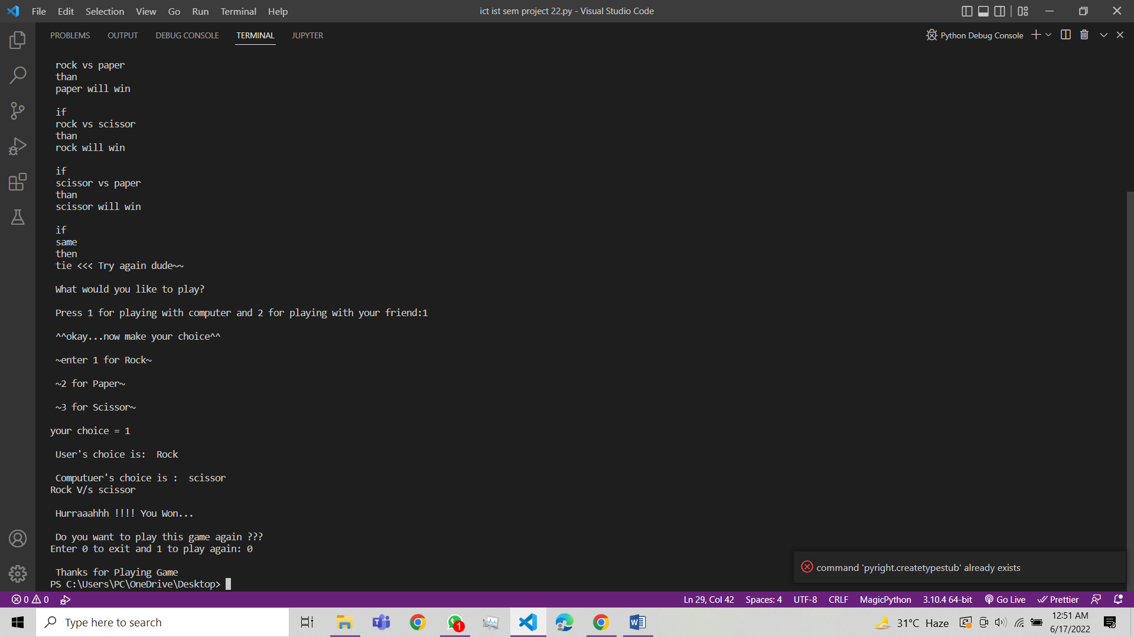

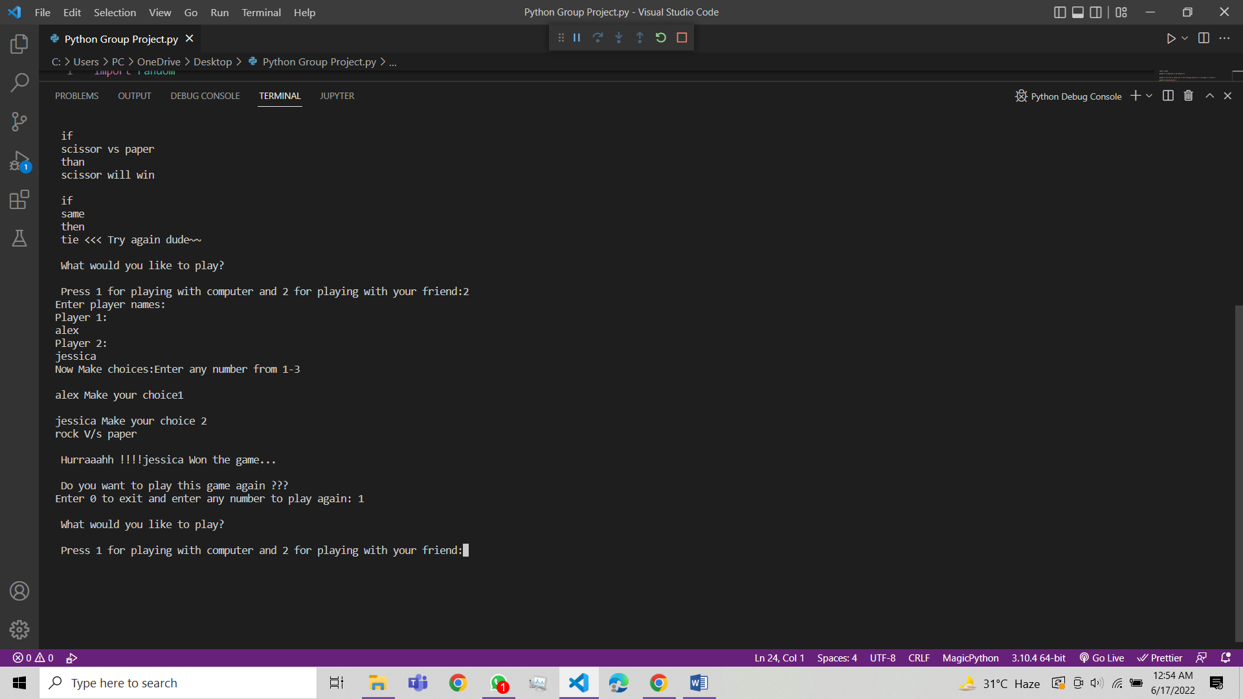

**Code:**

